Algorithm Analysis Fundamentals
Time complexity analysis of iterative and recursive algorithms; verify Big-O, Ω, Θ for sample programs
Student name : M.Kameshwaran (192572176) Department : B.E.CSE-AI
Course name & code : Design and analysis of algorithm - CSA0618

Experiment 1: Linear Search (Iterative)
- Objective: To analyze time complexity of linear search.
- Problem Statement: Write a Python program to search for a key in an array using linear search.
- Sample Input: [10, 25, 30, 45, 50], Key = 30
- Sample Output: Key found at index 2
- Complexity: Ω: O(1), O: O(n), Θ: Θ(n)
- Explanation: Demonstrates sequential scanning and inefficiency for large inputs.
Code:
#include<stdio.h>
int main(){
int a[]={10,25,30,45,50},k=30,i;
for(i=0;i<5;i++)
if(a[i]==k){
printf("Found at index %d",i);
return 0;
}
printf("Not found");
}
Output:
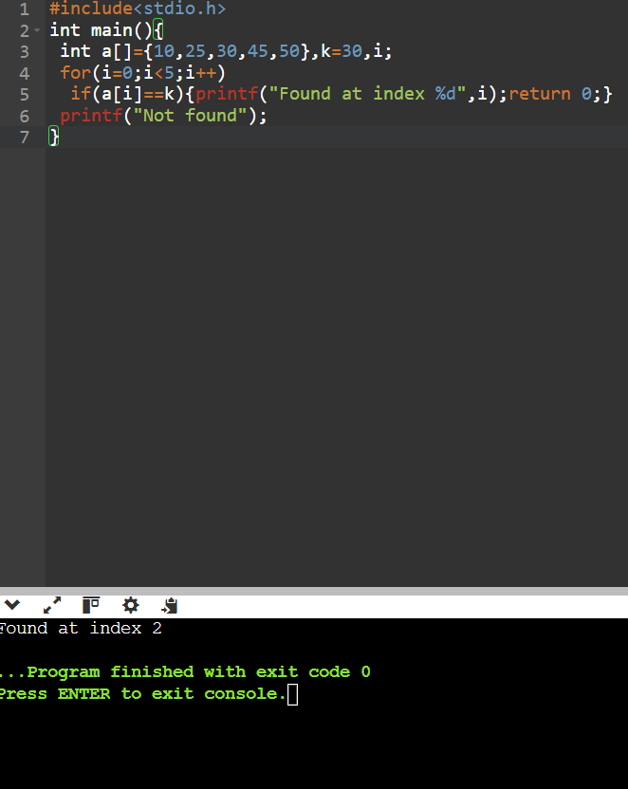

Experiment 2: Binary Search (Recursive)
- Objective: To compare recursive binary search complexity.
- Problem Statement: Implement recursive binary search in Python.
- Sample Input: [5, 10, 15, 20, 25], Key = 20
- Sample Output: Key found at index 3
- Complexity: Ω: O(1), O: O(log n), Θ: Θ(log n)
- Explanation: Shows divide-and-conquer and logarithmic efficiency.
Code :
#include<stdio.h>
int bs(int a[],int l,int h,int k){
if(l>h)return -1;
int m=(l+h)/2;
if(a[m]==k)return m;
if(k<a[m])return bs(a,l,m-1,k);
return bs(a,m+1,h,k);
}
int main(){
int a[]={5,10,15,20,25};
printf("Found at index %d",bs(a,0,4,20));
}

Output :
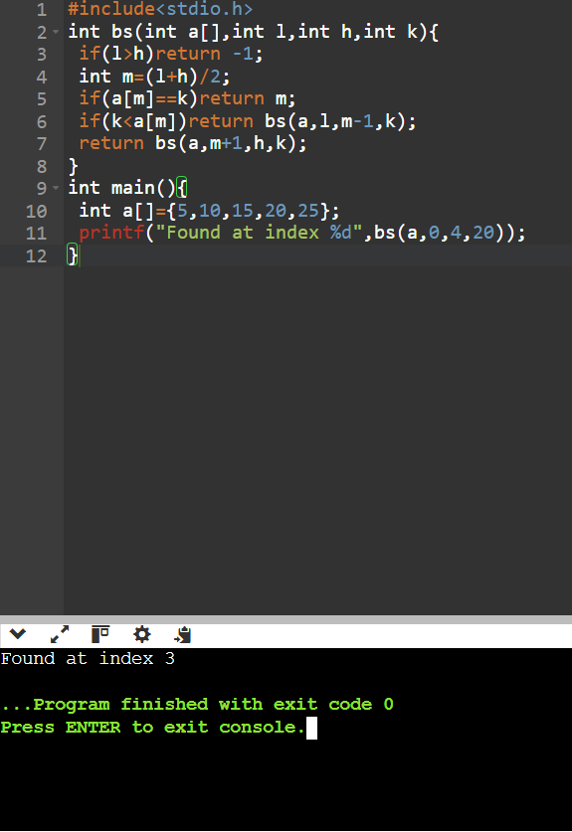

Experiment 3: Factorial (Iterative vs Recursive)
- Objective: To compare iterative and recursive factorial computation.
- Problem Statement: Write programs to compute factorial using both methods.
- Sample Input: n = 5
- Sample Output: 120
- Complexity: Both O(n)
- Explanation: Highlights recursion depth vs iterative loops.

Code :
#include<stdio.h>
int fact(int n){
return n? n*fact(n-1):1;
}
int main(){
int n=5;
printf("%d",fact(n));
}

Output:
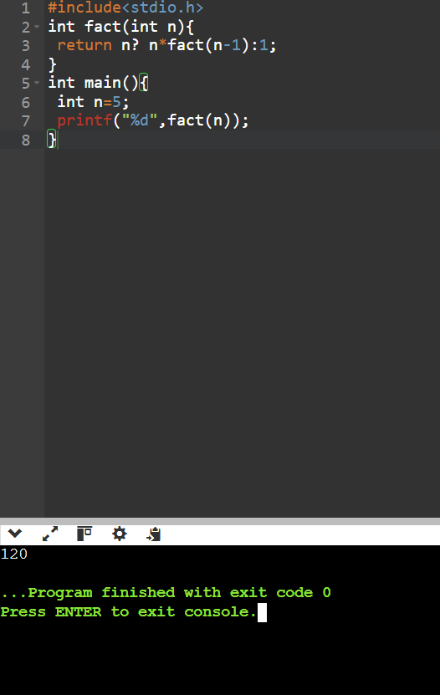

Experiment 4: Fibonacci Series
- Objective: To analyze recursive vs iterative Fibonacci generation.
- Problem Statement: Generate first n Fibonacci numbers.
- Sample Input: n = 6
- Sample Output: [0, 1, 1, 2, 3, 5]
- Complexity: Iterative O(n), Recursive naïve O(2n), Recursive with memoization O(n)
- Explanation: Illustrates exponential recursion vs efficient iteration.
Code :
#include<stdio.h>
int main(){
int n=6,a=0,b=1,c,i;
for(i=0;i<n;i++){
printf("%d ",a);
c=a+b;a=b;b=c;
}
}
Output:
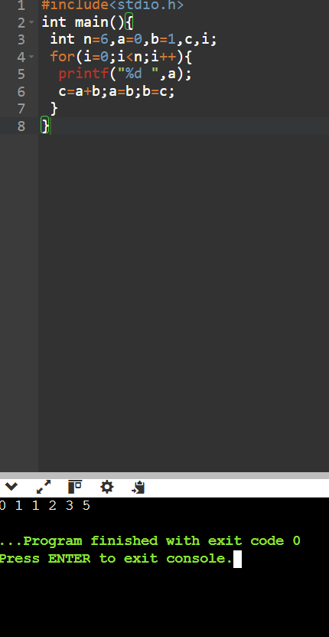

Experiment 5: Matrix Multiplication
- Objective: To analyze nested loop complexity.
- Problem Statement: Multiply two matrices using loops.
- Sample Input: A=[[1,2],[3,4]], B=[[5,6],[7,8]]
- Sample Output: [[19,22],[43,50]]
- Complexity: O(n3)
- Explanation: Shows cubic growth due to nested loops.
Code :
#include<stdio.h>
int main(){
int a[2][2]={{1,2},{3,4}},
b[2][2]={{5,6},{7,8}},
c[2][2]={0},i,j,k;
for(i=0;i<2;i++)
for(j=0;j<2;j++)
for(k=0;k<2;k++)
c[i][j]+=a[i][k]*b[k][j];
for(i=0;i<2;i++){
for(j=0;j<2;j++)printf("%d ",c[i][j]);
printf("\n");
}
}
Output :
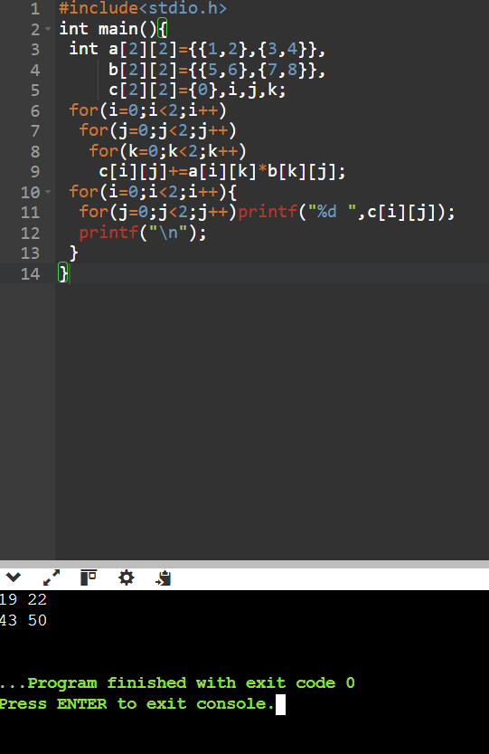

Experiment 6: Merge Sort
- Objective: To analyze divide-and-conquer sorting.
- Problem Statement: Implement merge sort.
- Sample Input: [38, 27, 43, 3, 9, 82, 10]
- Sample Output: [3, 9, 10, 27, 38, 43, 82]
- Complexity: Always O(nlog n)
- Explanation: Demonstrates guaranteed efficiency of divide-and-conquer.

Code :
#include<stdio.h>
void ms(int a[],int l,int r){
if(l>=r)return;
int m=(l+r)/2,i=l,j=m+1,k=0,t[20];
ms(a,l,m);ms(a,m+1,r);
while(i<=m&&j<=r)
t[k++]=a[i]<a[j]?a[i++]:a[j++];
while(i<=m)t[k++]=a[i++];
while(j<=r)t[k++]=a[j++];
for(i=l,k=0;i<=r;i++)a[i]=t[k++];
}
int main(){
int a[]={38,27,43,3,9,82,10},i;
ms(a,0,6);
for(i=0;i<7;i++)printf("%d ",a[i]);
}

Output :
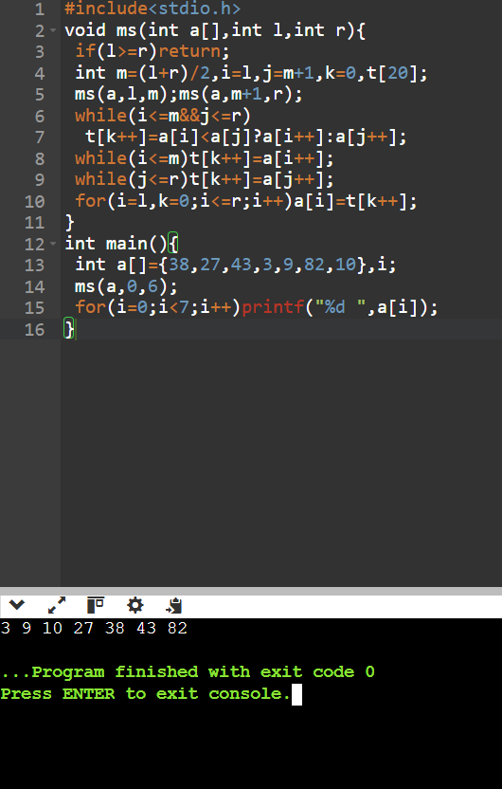

Experiment 7: Quick Sort
- Objective: To analyze recursive quick sort.
- Problem Statement: Implement quick sort.
- Sample Input: [10, 7, 8, 9, 1, 5]
- Sample Output: [1, 5, 7, 8, 9, 10]
- Complexity: Ω: O(nlog n), O: O(n2), Θ: Θ(nlog n)
- Explanation: Shows how pivot choice affects performance.
Code :
#include<stdio.h>
void q(int a[],int l,int h){
if(l>=h)return;
int i=l,j=h,p=a[h],t;
while(i<j){
while(a[i]<p)i++;
while(a[j]>=p&&j>i)j--;
if(i<j){t=a[i];a[i]=a[j];a[j]=t;}
}
t=a[i];a[i]=a[h];a[h]=t;
q(a,l,i-1);q(a,i+1,h);
}
int main(){
int a[]={10,7,8,9,1,5},i;
q(a,0,5);
for(i=0;i<6;i++)printf("%d ",a[i]);
}

Output :
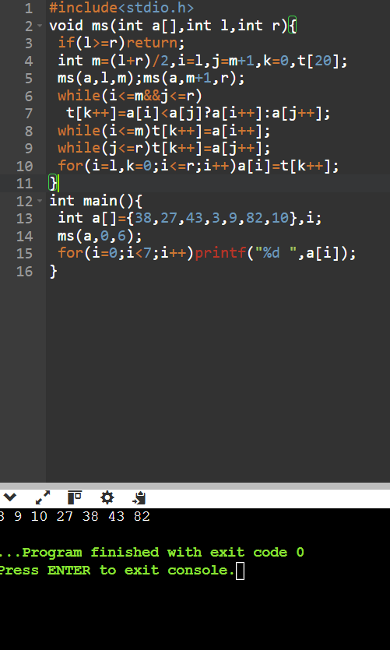

Experiment 8: Tower of Hanoi
- Objective: To analyze exponential recursion.
- Problem Statement: Solve Tower of Hanoi for n disks.
- Sample Input: n = 3
- Sample Output: Sequence of moves.
- Complexity: O(2n)
- Explanation: Illustrates exponential growth in recursive calls.
Code :
#include<stdio.h>
void h(int n,char a,char b,char c){
if(!n)return;
h(n-1,a,c,b);
printf("%c -> %c\n",a,c);
h(n-1,b,a,c);
}
int main(){
h(3,'A','B','C');
}

Output :
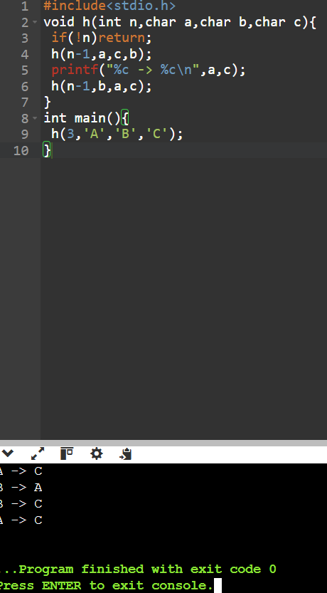

Experiment 9: GCD (Euclidean Algorithm)
- Objective: To analyze recursive GCD.
- Problem Statement: Implement Euclidean algorithm.
- Sample Input: a=48, b=18
- Sample Output: 6
- Complexity: O(log n)
- Explanation: Shows efficient recursion with logarithmic complexity.
Code :
#include<stdio.h>
int gcd(int a,int b){
return b?gcd(b,a%b):a;
}
int main(){
printf("%d",gcd(48,18));
}
Output :
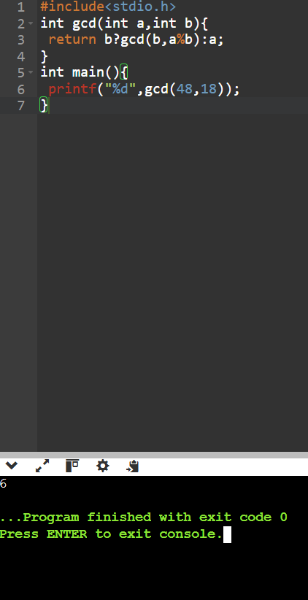

Experiment 10: Insertion Sort
- Objective: To analyze iterative sorting.
- Problem Statement: Implement insertion sort.
- Sample Input: [12, 11, 13, 5, 6]
- Sample Output: [5, 6, 11, 12, 13]
- Complexity: Ω: O(n), O: O(n2), Θ: Θ(n2)
- Explanation: Demonstrates input sensitivity (sorted vs unsorted).
Code :
#include<stdio.h>
int main(){
int a[]={12,11,13,5,6},i,j,k;
for(i=1;i<5;i++){
k=a[i];j=i-1;
while(j>=0&&a[j]>k)
a[j+1]=a[j--];
a[j+1]=k;
}
for(i=0;i<5;i++)printf("%d ",a[i]);
}

Output :
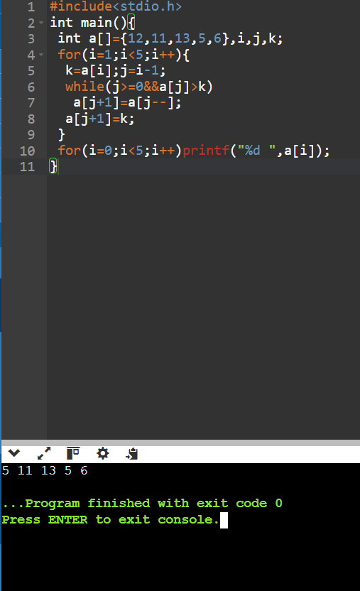

Experiment 11: Heap Sort
- Objective: To analyze heap-based sorting. ● Problem Statement: Implement heap sort.
- Sample Input: [4, 10, 3, 5, 1]
- Sample Output: [1, 3, 4, 5, 10]
- Complexity: Always O(nlog n)
- Explanation: Consistent performance using heap structure.

Code :
#include<stdio.h>
void heap(int a[],int n,int i){
int m=i,l=2*i+1,r=2*i+2,t;
if(l<n&&a[l]>a[m])m=l;
if(r<n&&a[r]>a[m])m=r;
if(m!=i){
t=a[i];a[i]=a[m];a[m]=t;
heap(a,n,m);
}
}
int main(){
int a[]={4,10,3,5,1},i,t,n=5;
for(i=n/2-1;i>=0;i--)heap(a,n,i);
for(i=n-1;i>0;i--){
t=a[0];a[0]=a[i];a[i]=t;
heap(a,i,0);
}
for(i=0;i<n;i++)printf("%d ",a[i]);
}
Output :
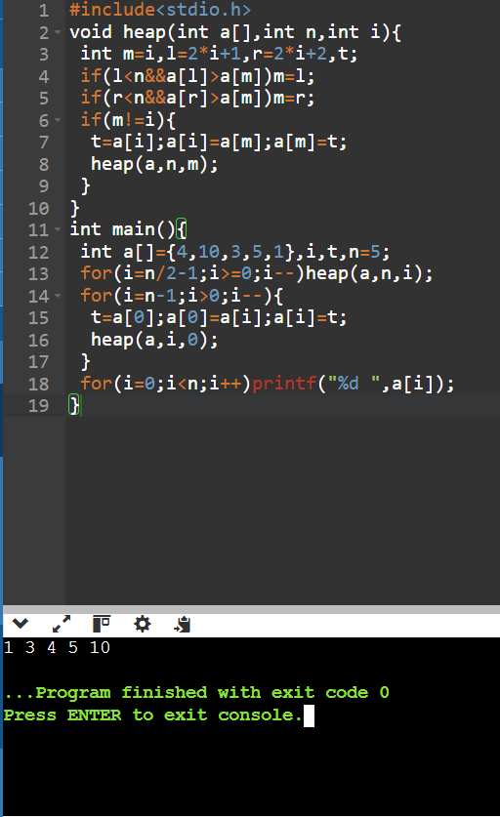

Experiment 12: Counting Inversions
- Objective: To analyze modified merge sort.
- Problem Statement: Count inversions in an array.
- Sample Input: [2, 4, 1, 3, 5]
- Sample Output: 3
- Complexity: O(nlog n)
- Explanation: Shows divide-and-conquer applied beyond sorting.
Code :
#include<stdio.h>
int main(){
int a[]={2,4,1,3,5},i,j,c=0;
for(i=0;i<5;i++)
for(j=i+1;j<5;j++)
if(a[i]>a[j])c++;
printf("%d",c);
}

Output :

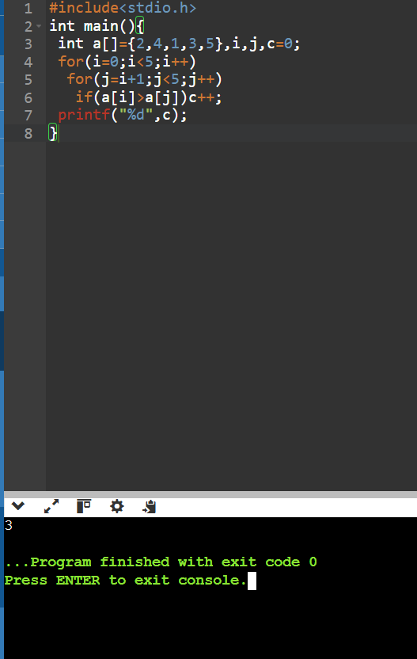

Experiment 13: Maximum Subarray Sum
- Objective: To compare Kadane’s vs divide-and-conquer.
- Problem Statement: Find maximum subarray sum.
- Sample Input: [-2, -3, 4, -1, -2, 1, 5, -3]
- Sample Output: 7
- Complexity: Kadane’s O(n), Divide & Conquer O(nlog n)
- Explanation: Highlights efficiency differences between approaches.

Code :
#include<stdio.h>
int main(){
int a[]={-2,-3,4,-1,-2,1,5,-3},i,s=a[0],m=a[0];
for(i=1;i<8;i++){
s=s+a[i]>a[i]?s+a[i]:a[i];
if(s>m)m=s;
}
printf("%d",m);
}
Output :
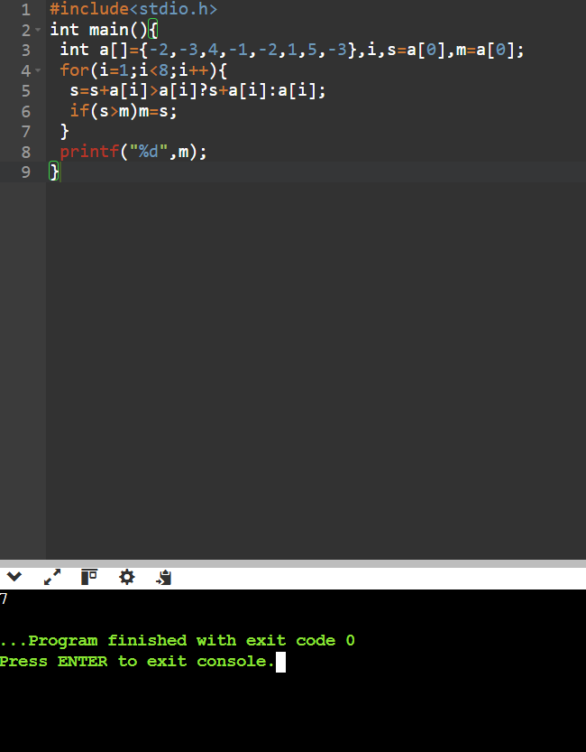

Experiment 14: Exponentiation
- Objective: To compare iterative vs recursive fast power.
- Problem Statement: Compute xn.
- Sample Input: x=2, n=10
- Sample Output: 1024
- Complexity: Iterative O(n), Recursive fast power O(log n) ● Explanation: Shows how recursion reduces complexity.
Code :
#include<stdio.h>
int power(int x,int n){
if(!n)return 1;
int y=power(x,n/2);
return n%2?y*y*x:y*y;
}
int main(){
printf("%d",power(2,10));
}

Output :
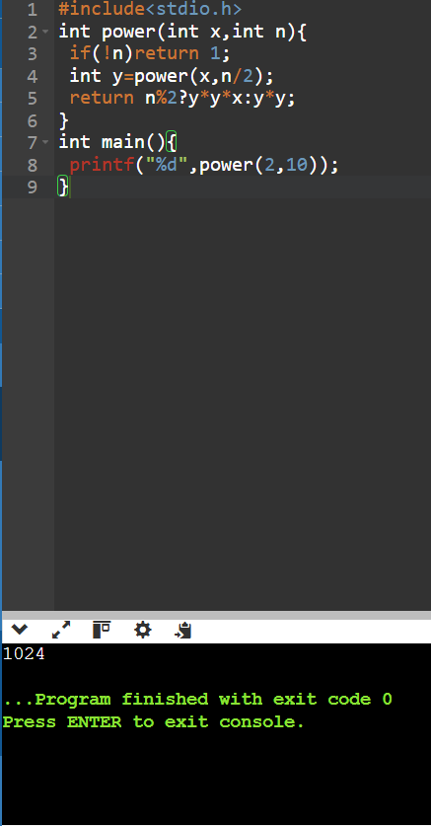

Experiment 15: Closest Pair of Points
- Objective: To analyze brute force vs divide-and-conquer.
- Problem Statement: Find closest pair of points in 2D.
- Sample Input: [(1,2), (4,5), (7,8), (3,1)]
- Sample Output: Closest pair (1,2)-(3,1), Distance = √5
- Complexity: Brute force O(n2), Optimized O(nlog n)
- Explanation: Demonstrates quadratic complexity and motivates optimization.

Code :

#include<stdio.h>
#include<math.h>
int main(){
int x[]={1,4,7,3},y[]={2,5,8,1},i,j,a=0,b=1;
double d,m=1e9;
for(i=0;i<4;i++)
for(j=i+1;j<4;j++){
d=hypot(x[i]-x[j],y[i]-y[j]);
if(d<m)m=d,a=i,b=j;
}
printf("(%d,%d)-(%d,%d) Distance=%.2f",
x[a],y[a],x[b],y[b],m);
}

Output :

